Week 3
- Modify your greeting program so that if the user does not enter a name (i.e. they just press enter), the program responds "Hello, Stranger!". Otherwise, it should print a greeting with their name as before.
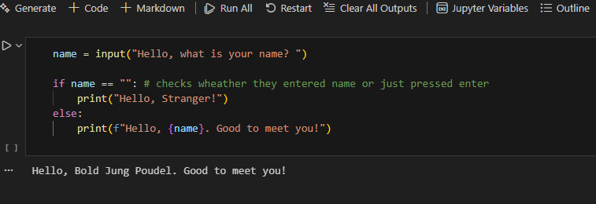

- Write a program that simulates the way in which a user might choose a password. The program should prompt a new password and then prompt again. If the two passwords entered are the same the program should say "Password Set" or similar, otherwise it should report an error.

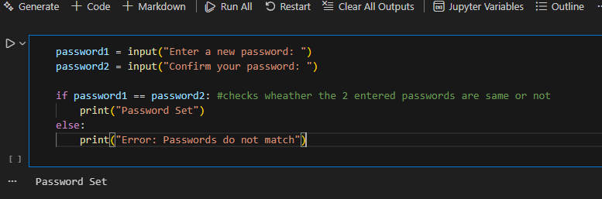

password1=saugat1234
password2=saugat1234

- Modify your previous program so that the password must be between 8 and 12 characters (inclusive) long.

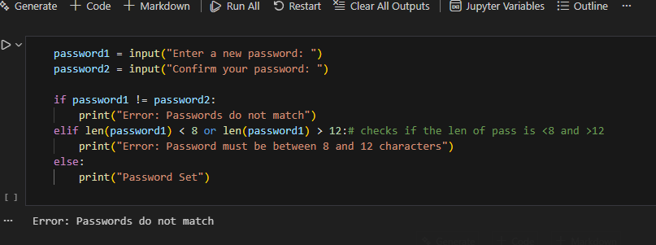

The password1=saugat1234
The password2=saugat12345

- Modify your program again so that the chosen password cannot be one of a list of common passwords, defined thus: BAD_PASSWORDS = ['password', 'letmein', 'sesame', 'hello', kendricklamar']
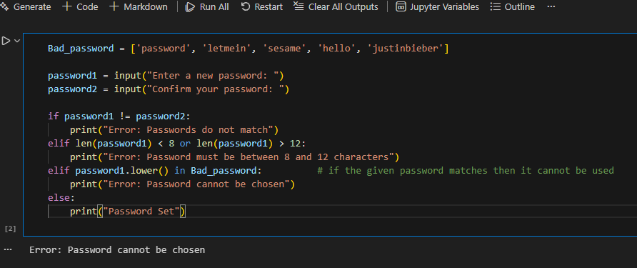

password1=password
password2=password

- Modify your program a final time so that it executes until the user successfully chooses a password. That is, if the password chosen fails any of the checks, the program should return to asking for the password the first time.
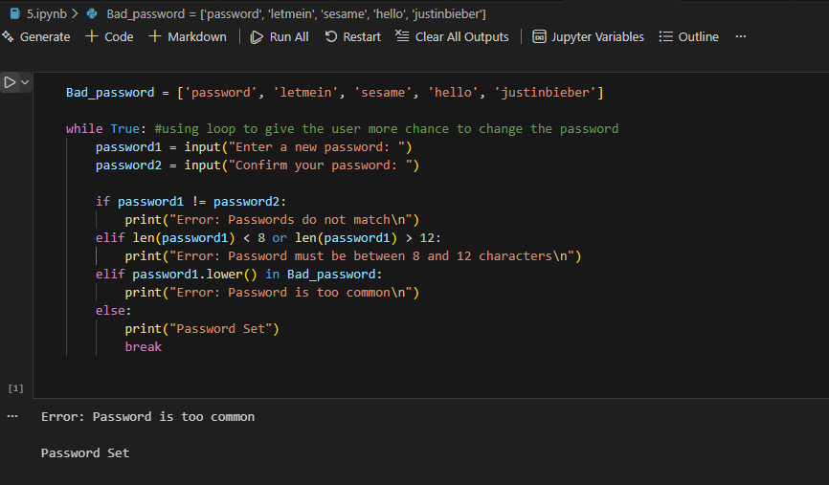

- Write a program that displays the "Seven Times Table". That is, the result of multiplying 7 by every number from 0 to 12 inclusive. The output might start: 0 x 7 = 0 1 x 7 = 7 2 x 7 = 14 and so on.
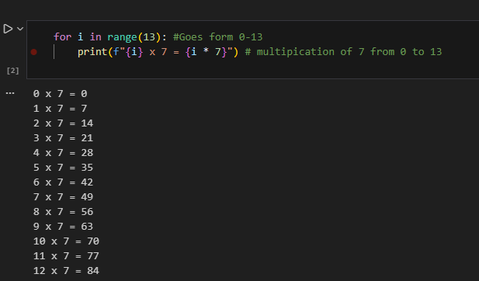

- Modify your "Times Table" program so that the user enters the number of the table they require. This number should be between 0 and 12 inclusive
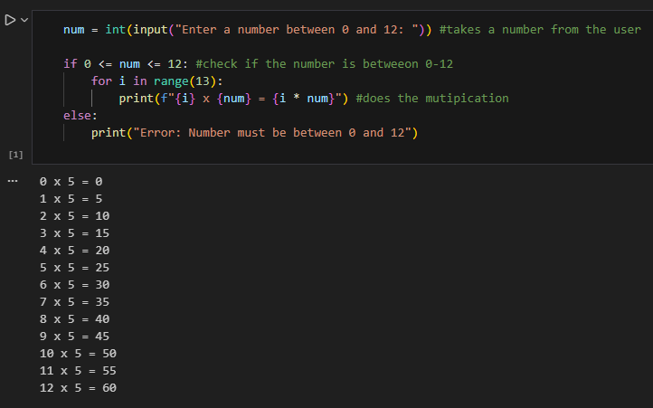

Num=5
- Modify the "Times Table" again so that the user still enters the number of the table, but if this number is negative the table is printed backwards. So, entering "-7" would produce the Seven Times Table starting at "12 times" down to "0 times"
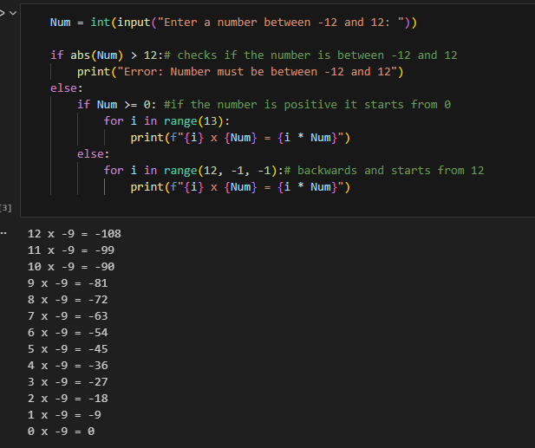
Num=-9

